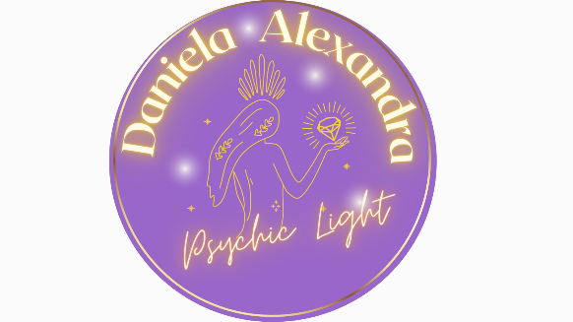

**Privacy Policy**

**Effective Date: 12 February 2022  
Website:** [**www.daniela.nz**](http://www.daniela.nz) **Contact: daniela.alexandra10@yahoo.co.nz | 021 521 640**

**1. Introduction**

**This Privacy Policy explains how Daniela Schlecht, trading as Daniela Psychic Light, collects, uses, stores, and protects your personal information in accordance with the New Zealand Privacy Act 2020.**

**By using our website or services, you agree to the terms outlined in this Privacy Policy.**

**2. Purpose of Collection**

**We collect personal information to:**

* **Provide and manage services**
* **Communicate with clients**
* **Analyse website performance**
* **Send updates or marketing (with consent)**
* **Comply with legal obligations**

**3. Information We Collect**

**We collect only the personal data necessary to provide services or improve the user experience. This may include:**

**Data Collected Automatically**

* **IP address and location**
* **Pages visited and links clicked**
* **Browser/device type**
* **Content viewed**
* **Cookies (see section 10)**

**Data You Provide Directly**

* **Name**
* **Email address**
* **Phone number**
* **Address details**
* **Age group**
* **Messages or requests submitted via forms or email**

**4. Legal Basis for Collection**

**We collect personal information only when:**

* **It is necessary for a service you’ve requested**
* **You have given us consent**
* **It is required by law**
* **It is necessary to protect health, safety, or legal rights**

**5. Use of Your Personal Information**

**Your information may be used to:**

* **Confirm appointments and send reminders**
* **Respond to enquiries**
* **Provide customer service and support**
* **Improve site usability and marketing efforts**
* **Comply with any legal obligations**

**We will not use your information for unrelated purposes without your consent.**

**6. Sharing of Personal Information**

**We do not sell your personal information.**

**We may share it with:**

* **Our staff, for business purposes only**
* **Government agencies if legally required**
* **A purchaser if the business is sold (under strict confidentiality)**

**We are not responsible for the privacy practices of third-party websites linked on our site.**

**7. Data Storage and Security**

**We store personal data securely using:**

* **Encrypted website connections**
* **Secure servers**
* **Access restrictions to authorised staff only**
* **Confidentiality agreements with team members**

**While we take all reasonable precautions, no system is entirely secure. You use our website at your own risk.**

**8. Your Rights**

**Under the Privacy Act 2020, you have the right to:**

* **Access the personal information we hold about you**
* **Request correction of inaccurate or incomplete data**
* **Withdraw your consent to data use**
* **Lodge a complaint with the Office of the Privacy Commissioner if you believe your data has been misused**

**To exercise these rights, contact:**

**Daniela Schlecht  
📧 daniela.alexandra10@yahoo.co.nz  
📞 021 521 640**

**9. Children's Privacy**

**We do not knowingly collect data from children under 16 years. If we become aware that personal data has been provided by a minor, it will be deleted promptly. Parents or guardians can contact us for immediate removal.**

**10. Cookie Policy**

**Cookies are small files that enhance your website experience.**

**We use:**

* **Functional cookies: Remember your settings for future visits**
* **Analytical cookies: Help us understand site usage**
* **Targeting cookies: Tailor promotions to your interests**
* **Third-party cookies: Track data via trusted services like Google**

**You can manage or disable cookies in your browser settings. Disabling them may affect website performance.**

**11. Retention of Personal Data**

**We retain personal data only for as long as it is required to:**

* **Fulfill the purpose for which it was collected**
* **Comply with legal, regulatory, or tax requirements**

**12. Changes to This Policy**

**We may update this Privacy Policy from time to time to reflect legal changes or service updates. The most recent version will always be available on our website.**

**Last updated: 12 February 2022**