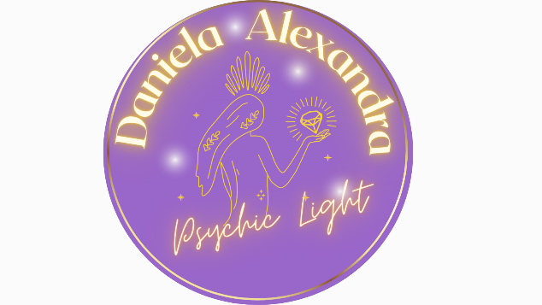**Terms of Service**

**Effective Date:** [1st April 2025]  
**Business Name:** Psychic Light Daniela  
**Contact:** daniela.alexandra10@yahoo.co.nz | 021 521 640

**1. Overview**

This website is operated by **Psychic Light Daniela**. By accessing or purchasing from this site, you agree to be bound by the Terms of Service outlined here. These terms apply to all site users, including customers, vendors, and browsers.

We may update these Terms at any time. Continued use of the site after updates constitutes acceptance of the revised terms.

**2. Disclaimer – Psychic Services**

Psychic readings, spiritual guidance, and intuitive services offered by Psychic Light Daniela are for **informational and entertainment purposes only**. No guarantees are made regarding the accuracy, relevance, or outcomes of the insights provided.

You are responsible for your own decisions and actions resulting from services received. Services are not a substitute for legal, financial, psychological, or medical advice.

**3. Disclaimer – No Medical or Health Advice**

The content and services provided by Psychic Light Daniela do **not constitute medical, mental health, or healthcare advice**. We do not diagnose, treat, or cure any physical or psychological conditions.

Always consult with a qualified medical or mental health professional for any concerns about your health or well-being.

**4. Eligibility**

By using this website, you confirm that:

* You are at least the legal age of majority in your region, or
* You are of majority age and have given permission for minors in your care to access the site.

**5. Use of Services**

You agree not to:

* Use our services for unlawful purposes
* Violate any local or international laws
* Upload or transmit malicious code or viruses

Violation of these terms may result in immediate service termination.

**6. Products & Services**

Some products or services may be available exclusively online and in limited quantities. We reserve the right to:

* Limit sales by region or individual
* Modify or discontinue any service without notice
* Refuse or cancel any order at our discretion

Refer to our Booking & Cancellation Policy for more details on refunds and returns.

**7. Payment & Account Information**

You agree to provide current and accurate billing information. We reserve the right to:

* Refuse or cancel orders suspected of fraud or abuse
* Limit quantities ordered per user or household

**8. Third-Party Tools and Links**

We may offer tools or links provided by third parties. We do not endorse or control these and are not responsible for their content or services.

**9. User Content and Feedback**

You may submit comments, feedback, or ideas. By doing so, you grant us the right to use and share that content without compensation. We reserve the right to remove any content we deem inappropriate or unlawful.

**10. Intellectual Property**

All content on this site, including images, text, logos, and designs, is the property of Psychic Light Daniela and may not be used or reproduced without permission.

**11. Limitation of Liability**

All services and content are provided “as is” without any warranties. We are not liable for:

* Losses or damages resulting from service use
* Decisions made based on readings or guidance
* Any indirect or consequential damages

Some limitations may not apply in jurisdictions that do not allow exclusion of liability.

**12. Indemnification**

You agree to indemnify and hold harmless Psychic Light Daniela and its representatives from any claims, damages, or expenses arising from your breach of these Terms or misuse of services.

**13. Termination**

We may suspend or terminate your access to services at any time for violations of these Terms. You may also terminate your use of the site at any time.

**14. Governing Law**

These Terms are governed by the laws of **New Zealand**. Any disputes shall be handled in New Zealand jurisdiction.

**15. Contact Information**

If you have questions about these Terms, please contact:

**Psychic Light Daniela**  
📍 6 Macadamia Lane, Waipapa 0295  
📧 daniela.alexandra10@yahoo.co.nz  
📞 021 521 640